|  |
| --- |
| College LaSalle |
| Project - Oriented Object Programming User and Technical Manual |
|  |
| Presented to: Mihai Maftei. |

|  |
| --- |
| Your name: Diego Tordoya  4/18/2023  Version: 3.0 |

1. **Start by adding a short description of your project, and the languages (technologies) used:**
2. Language: C#.Net Framework
3. Tools (IDE): Visual Studio Community 2022
4. **Present the print screens of yours forms, and have a detailed description of the functionalities (step by step).**

**The main form presents a multiform who contains (6 form on the top)**

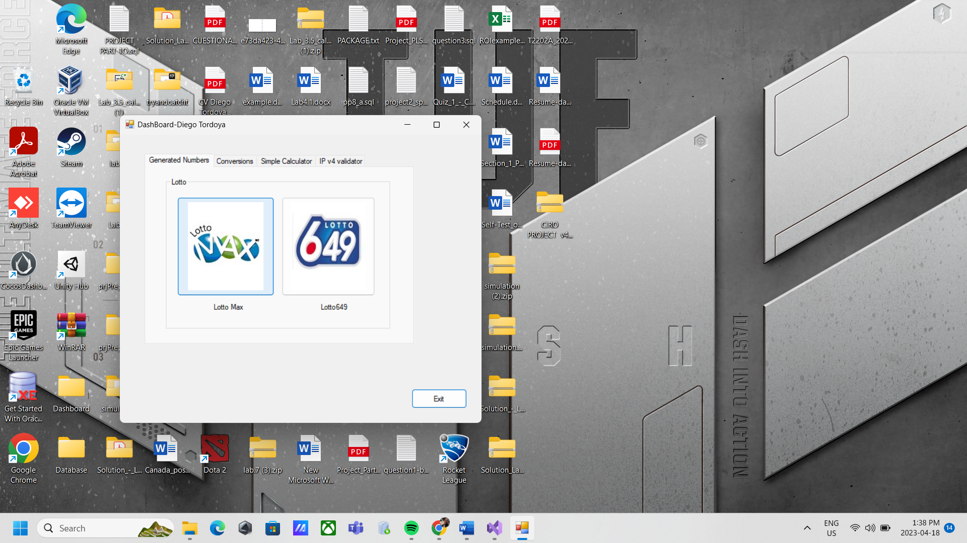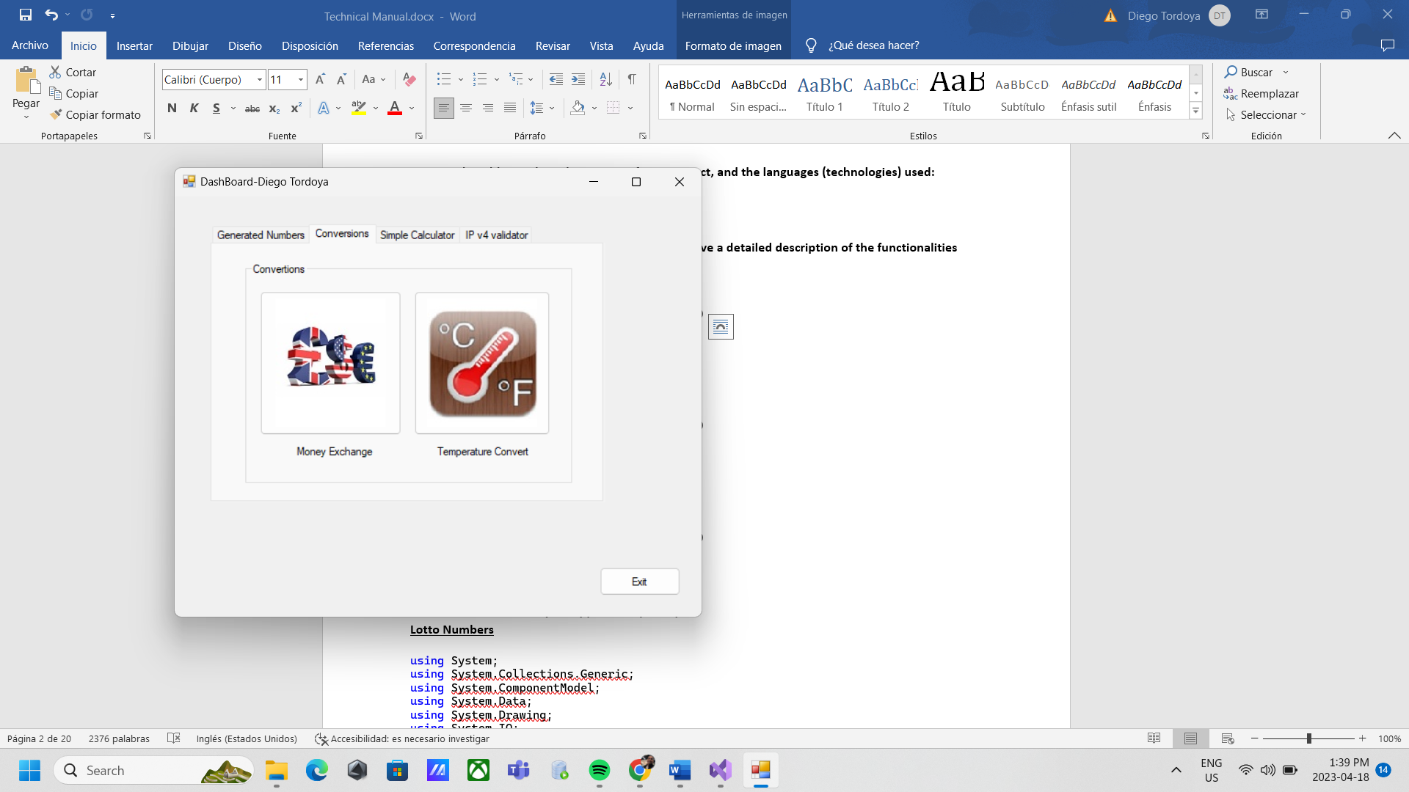

**Lottery Numbers Money Exchange & Temperature Conversions**

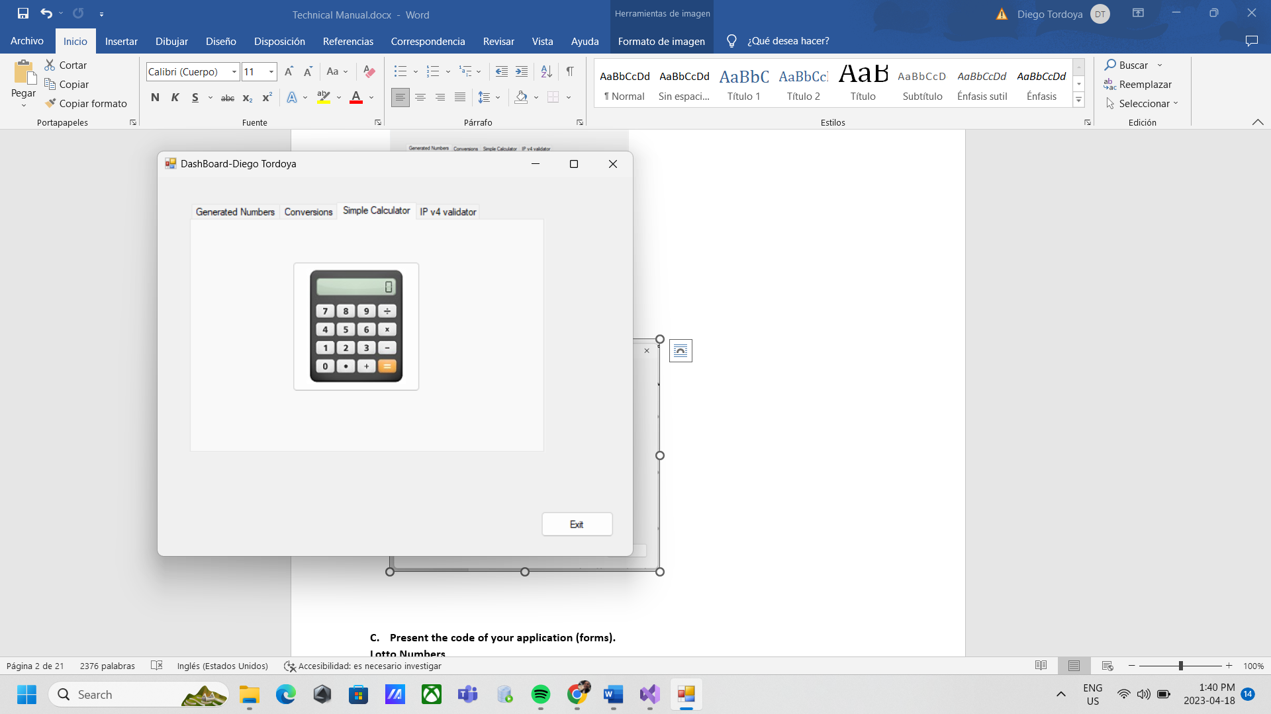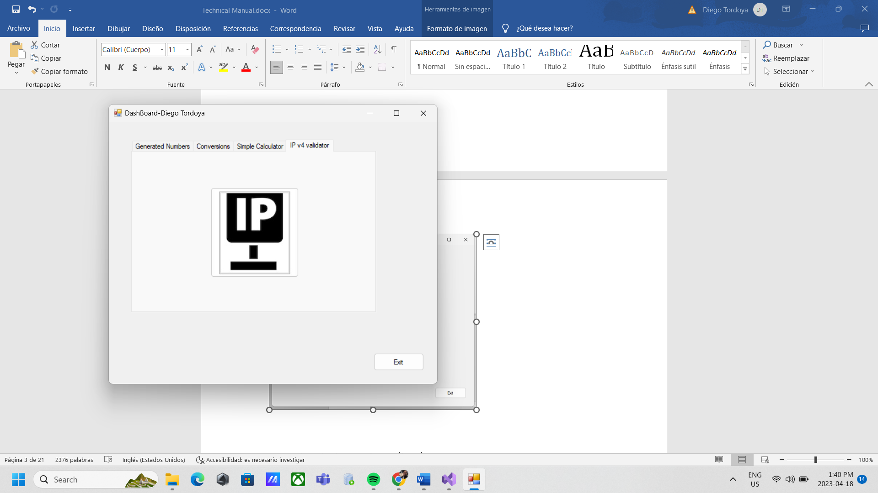

**Calculator IP4 Validator**

**The application form of the Lotto max generates 7 random numbers when you press generate button. Also, when you press the button read file it shows the numbers and the bonus number and also keep save into the text file**

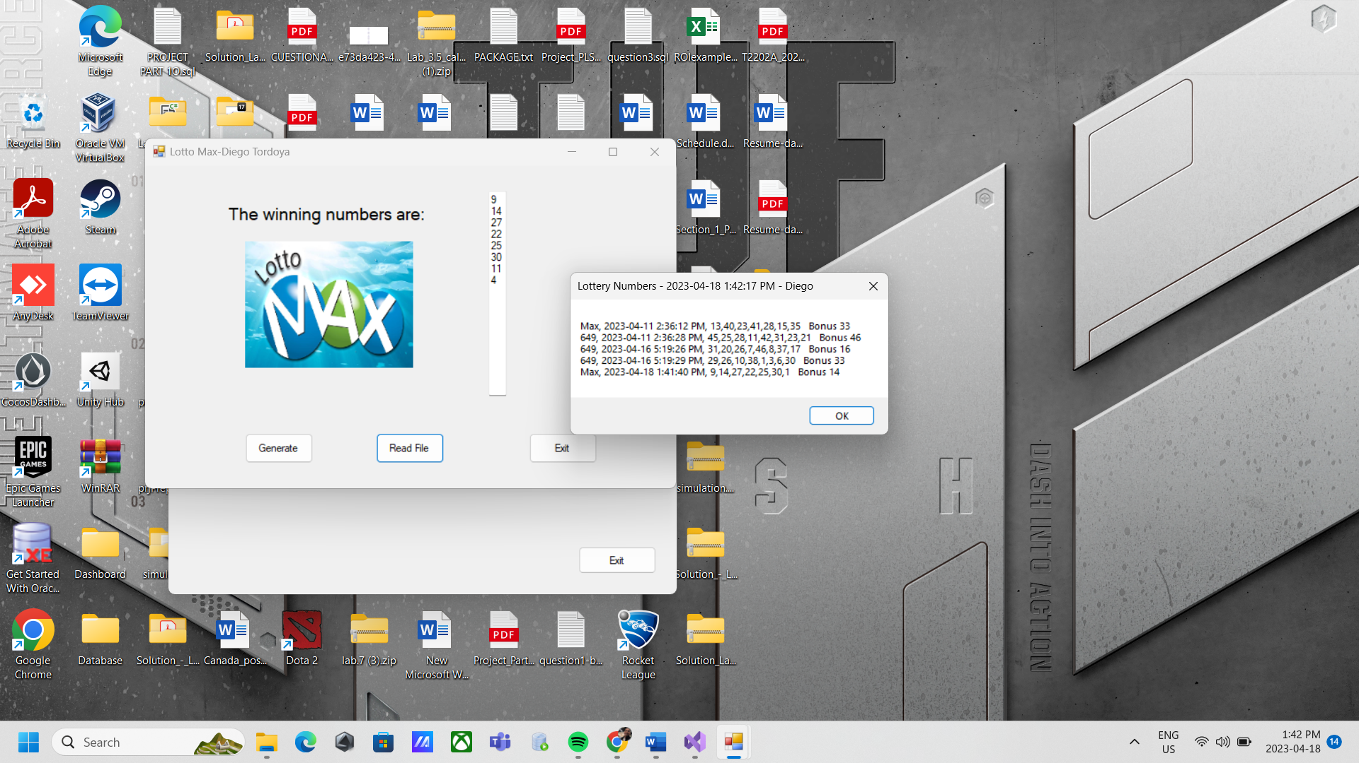

**The application form of the Lotto max generates 8 random numbers when you press generate button. Also, when you press the button read file it shows the numbers and the bonus number and also keep save into the text file**

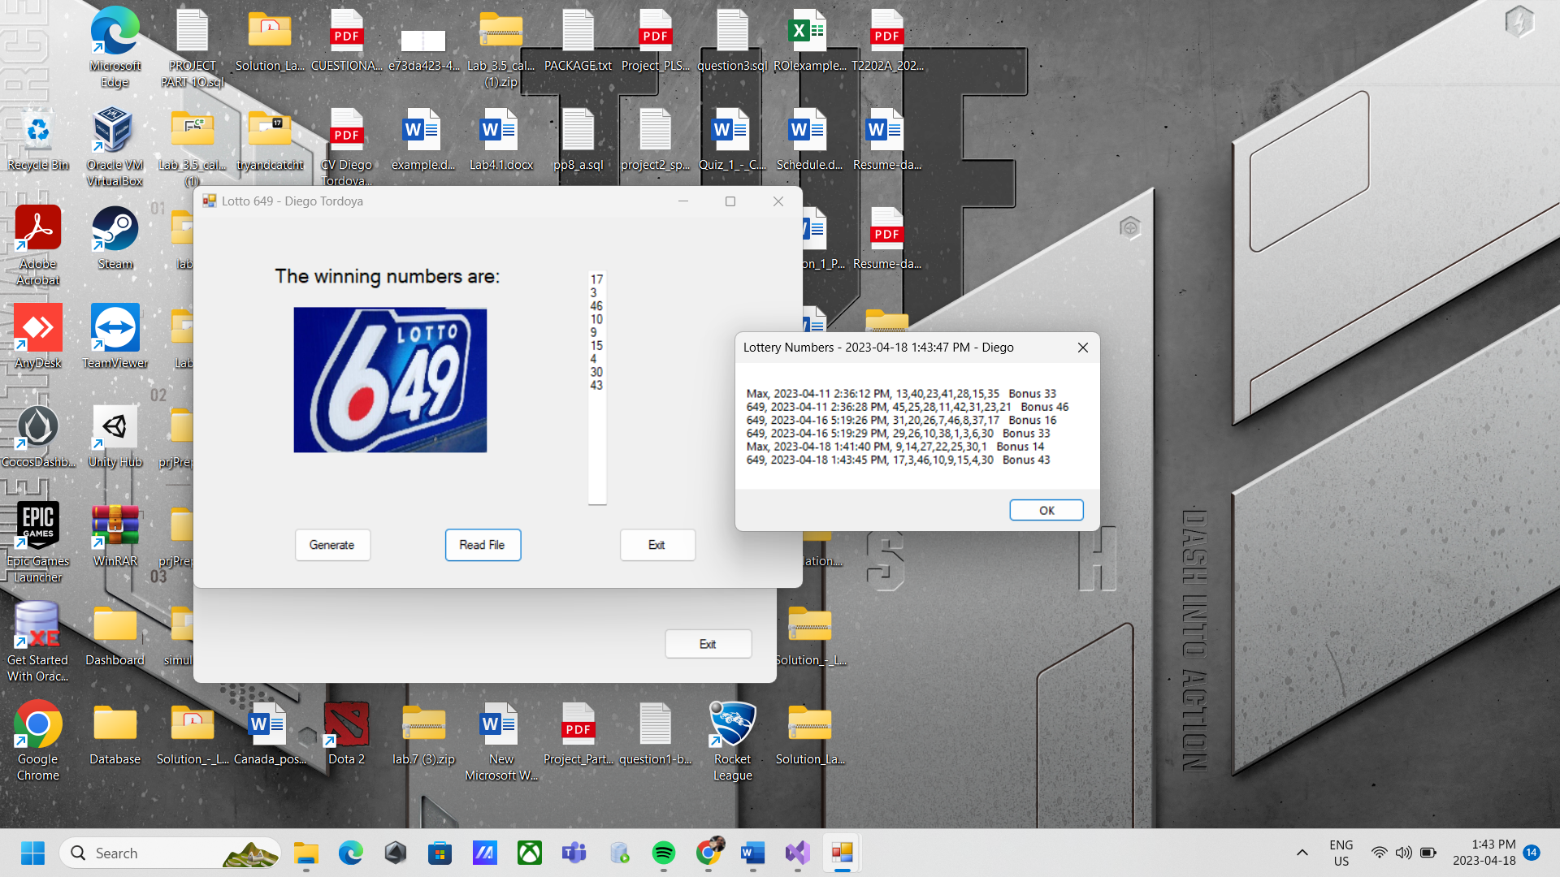

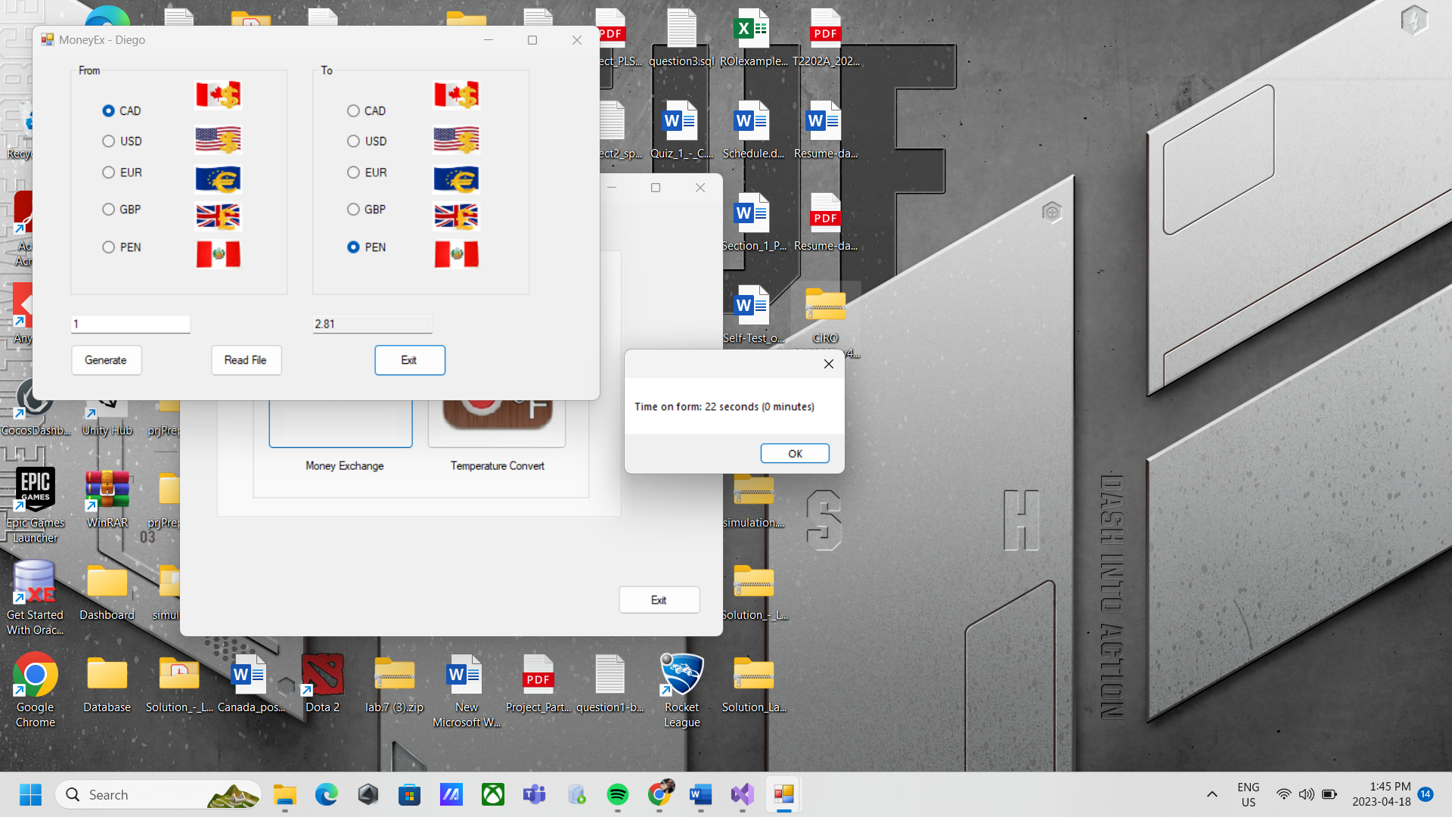

**The application form of the Money Exchange converts all the number that you put into the textbox on the left and appears in the right textbox. You could change the currency money as you preferred. Also, when you press the button read file it shows the conversions keep save into the text file until you close the application a window appears and shows the time that you spend in the form.**

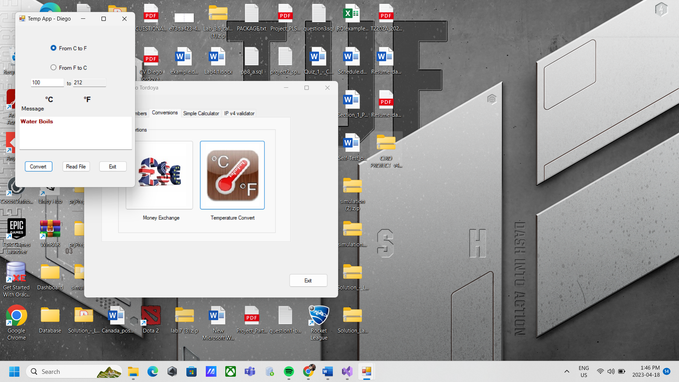

**The application form of the Temperature converts all the number that you put into the textbox on the left and appears in the right textbox. You could change the C to F or reverse as you preferred. Under the temperature conversion it appears a text in some cases when the temperature is too hot or cold. Also, when you press the button read file it shows the conversions keep save into the text file until you close the application a window appears and shows the time that you spend in the form.**

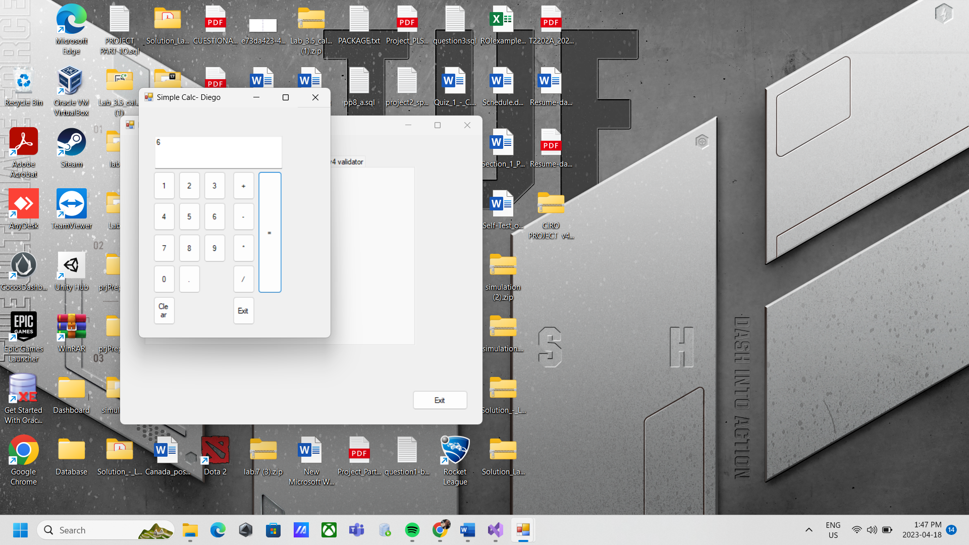

**The application form of the Calculator does the operation of the numbers that you press on the buttons and shows into the textbox. You could change the operation (+, /, *, -) as you preferred. The form has a clear button for delete the numbers in the textbox. Also, all the operations keep saves into the text file.**

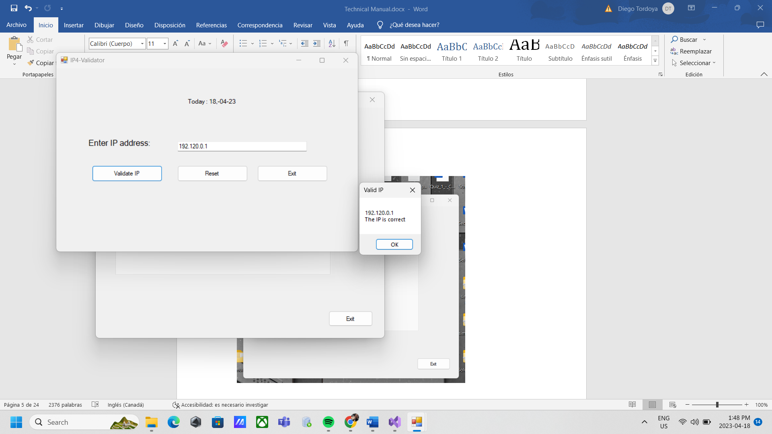

**The application form of the IP4Validator does the validation of the numbers that you put into the textbox. You could clear the numbers when you press the button reset the operation. Also, when you press the button validate all the numbers keep save into a binary file until you close the application a window appears and shows the time that you spend in the form.**

1. **Present the code of your application (forms).**

**Lotto Numbers**

using System;

using System.Collections.Generic;

using System.ComponentModel;

using System.Data;

using System.Drawing;

using System.IO;

using System.Linq;

using System.Text;

using System.Threading.Tasks;

using System.Windows.Forms;

using static System.Windows.Forms.VisualStyles.VisualStyleElement;

namespace FinalProject

{

public partial class frmMax : Form

{

public frmMax()

{

InitializeComponent();

}

private void Form3_Load(object sender, EventArgs e)

{

}

private void button3_Click(object sender, EventArgs e)

{

if (MessageBox.Show("Do you want to quit this application?", "Exit ?", MessageBoxButtons.YesNo).ToString() == "Yes")

{

this.Close();

}

}

private void button1_Click(object sender, EventArgs e)

{

Random random = new Random();

List<int> numbers = new List<int>();

string lotteryName = "";

int maxNumber = 0;

{

lotteryName = "Max";

maxNumber = 50;

}

while (numbers.Count < (lotteryName == "Max" ? 7 : 8))

{

int randomNumber = random.Next(1, maxNumber + 1);

if (!numbers.Contains(randomNumber))

{

numbers.Add(randomNumber);

}

}

string bonusNumber = "";

{

bonusNumber = "" + random.Next(1, 50);

}

string filePath = "LottoNbrs.txt";

using (StreamWriter sw = new StreamWriter(filePath, true))

{

string numbersString = string.Join(",", numbers);

string line = lotteryName + ", " + DateTime.Now.ToString("yyyy/MM/dd h:mm:ss tt") + ", " + numbersString + " Bonus "+ bonusNumber;

sw.WriteLine(line);

}

string generatedNumbersString = string.Join(Environment.NewLine, numbers);

generatedNumbersString += bonusNumber;

MaxTextbox.Text = generatedNumbersString;

}

private void button2_Click(object sender, EventArgs e)

{

string filePath = "LottoNbrs.txt";

string content = "";

if (File.Exists(filePath))

{

using (FileStream fs = new FileStream(filePath, FileMode.Open, FileAccess.Read))

{

using (StreamReader sr = new StreamReader(fs))

{

while (!sr.EndOfStream)

{

string line = sr.ReadLine();

content += line + Environment.NewLine;

}

}

}

}

else

{

content = "File does not exist.";

}

string title = "Lottery Numbers - " + DateTime.Now.ToString("yyyy/MM/dd h:mm:ss tt") + " - Diego";

MessageBox.Show(content, title);

}

}

}

using System;

using System.Collections.Generic;

using System.ComponentModel;

using System.Data;

using System.Drawing;

using System.IO;

using System.Linq;

using System.Text;

using System.Threading.Tasks;

using System.Windows.Forms;

using static System.Windows.Forms.VisualStyles.VisualStyleElement;

namespace FinalProject

{

public partial class frm649 : Form

{

public frm649()

{

InitializeComponent();

}

private void label1_Click(object sender, EventArgs e)

{

}

private void Form2_Load(object sender, EventArgs e)

{

}

private void button3_Click(object sender, EventArgs e)

{

if (MessageBox.Show("Do you want to quit this application?", "Exit ?", MessageBoxButtons.YesNo).ToString() == "Yes")

{

this.Close();

}

}

private void button1_Click(object sender, EventArgs e)

{

Random random = new Random();

List<int> numbers = new List<int>();

string lotteryName = "";

lotteryName = "649";

int maxNumber = 49;

while (numbers.Count < (lotteryName == "Max" ? 7 : 8))

{

int randomNumber = random.Next(1, maxNumber + 1);

if (!numbers.Contains(randomNumber))

{

numbers.Add(randomNumber);

}

}

string bonusNumber = ""+random.Next(1, 49);

string filePath = "LottoNbrs.txt";

using (StreamWriter sw = new StreamWriter(filePath, true))

{

string numbersString = string.Join(",", numbers);

string line = lotteryName + ", " + DateTime.Now.ToString("yyyy/MM/dd h:mm:ss tt") + ", " + numbersString +" Bonus " +bonusNumber;

sw.WriteLine(line);

}

string generatedNumbersString = string.Join(Environment.NewLine, numbers);

generatedNumbersString += bonusNumber;

LottoTextbox.Text = generatedNumbersString;

}

private void button2_Click(object sender, EventArgs e)

{

string filePath = "LottoNbrs.txt";

string content = "";

if (File.Exists(filePath))

{

using (FileStream fs = new FileStream(filePath, FileMode.Open, FileAccess.Read))

{

using (StreamReader sr = new StreamReader(fs))

{

while (!sr.EndOfStream)

{

string line = sr.ReadLine();

content += line + Environment.NewLine;

}

}

}

}

else

{

content = "File does not exist.";

}

string title = "Lottery Numbers - " + DateTime.Now.ToString("yyyy/MM/dd h:mm:ss tt") + " - Diego";

MessageBox.Show(content, title);

}

}

}

**Money Exchange**

using System;

using System.Collections.Generic;

using System.ComponentModel;

using System.Data;

using System.Drawing;

using System.IO;

using System.Linq;

using System.Text;

using System.Text.RegularExpressions;

using System.Threading.Tasks;

using System.Windows.Forms;

using static System.Windows.Forms.VisualStyles.VisualStyleElement;

namespace FinalProject

{

public partial class MoneyExchange : Form

{

private DateTime startTime;

private DateTime endTime;

private string newfromValue;

//CAD = 1.00 -> PEN = 2.81

//CAD = 1.00 -> USD = 0.75

//CAD = 1.00 -> EUR = 0.68

//CAD = 1.00 -> GBP = 0.60

public MoneyExchange()

{

InitializeComponent();

}

private void button3_Click(object sender, EventArgs e)

{

if (MessageBox.Show("Do you want to quit this application Money Exchange?", "Exit ?", MessageBoxButtons.YesNo).ToString() == "Yes")

{

// Set the end time to the current time

endTime = DateTime.Now;

// Calculate the time difference in seconds and minutes

TimeSpan timeDiff = endTime - startTime;

int seconds = (int)timeDiff.TotalSeconds;

int minutes = (int)timeDiff.TotalMinutes;

// Display the time on the form using a MessageBox

string message = $"Time on form: {seconds} seconds ({minutes} minutes)";

MessageBox.Show(message);

this.Close();

}

}

private void MoneyExchange_Load(object sender, EventArgs e)

{

// Set the start time to the current time

startTime = DateTime.Now;

}

private void radioButton1_CheckedChanged(object sender, EventArgs e)

{

}

private void button1_Click(object sender, EventArgs e)

{

decimal cad = 1.00m;

decimal usd = 0.75m;

decimal eur = 0.68m;

decimal gbp = 0.60m;

decimal pen = 2.81m;

decimal fromValue = 0;

decimal toValue = 0;

decimal convertedValue = 0m;

string fromCurrency = "";

string toCurrency = "";

try

{

string valueInserted = textBox1.Text.Trim();

Regex codeRegex = new Regex(@"^\d{1,3}(,\d{3})*(\.\d+)?$");

if (textBox1.Text == "")

{

throw new Exception("Please, insert a value to be converted.");

}

else if (!codeRegex.IsMatch(valueInserted))

{

throw new Exception("Please enter currency values using the US Standard $ 1,000.00");

}

else

{

foreach (RadioButton radioButton1 in groupBox1.Controls.OfType<RadioButton>())

{

if (radioButton1.Checked)

{

switch (radioButton1.Text)

{

case "CAD":

fromValue = cad;

fromCurrency = "CAD";

break;

case "USD":

fromValue = usd;

fromCurrency = "USD";

break;

case "EUR":

fromValue = eur;

fromCurrency = "EUR";

break;

case "GBP":

fromValue = gbp;

fromCurrency = "GBP";

break;

case "PEN":

fromValue = pen;

fromCurrency = "PEN";

break;

default:

break;

}

}

}

foreach (RadioButton radioButton2 in groupBox2.Controls.OfType<RadioButton>())

{

if (radioButton2.Checked)

{

switch (radioButton2.Text)

{

case "CAD":

toValue = cad;

toCurrency = "CAD";

break;

case "USD":

toValue = usd;

toCurrency = "USD";

break;

case "EUR":

toValue = eur;

toCurrency = "EUR";

break;

case "GBP":

toValue = gbp;

toCurrency = "GBP";

break;

case "PEN":

toValue = pen;

toCurrency = "PEN";

break;

default:

break;

}

}

}

convertedValue = Convert.ToDecimal(textBox1.Text) * toValue / fromValue;

textBox2.Text = convertedValue.ToString("0.00");

}

}

catch (Exception ex)

{

MessageBox.Show(ex.Message);

textBox1.Focus();

}

string path = "moneyConversion.txt";

FileStream fs1 = null;

try

{

fs1 = new FileStream(path, FileMode.Append, FileAccess.Write);

StreamWriter textOut = new StreamWriter(fs1);

textOut.WriteLine($"{newfromValue} {fromCurrency} = {convertedValue.ToString("0.00")} {toCurrency} {DateTime.Now.ToString("yyyy-MM-dd h:mm:ss tt")}");

textOut.Close();

}

catch (FileNotFoundException)

{

MessageBox.Show(path + " not found.", "File Not Found");

}

catch (DirectoryNotFoundException)

{

MessageBox.Show(path + " not found.", "Directory Not Found");

}

catch (IOException ex)

{ MessageBox.Show(ex.Message, "IOException"); }

finally { if (fs1 != null) fs1.Close(); }

}

private void button2_Click(object sender, EventArgs e)

{

try

{

using (StreamReader f1 = new StreamReader("moneyConversion.txt"))

{

string contents = f1.ReadToEnd();

if (contents != null && contents.Trim() != "")

{

MessageBox.Show(contents, "Money Conversion - Diego", MessageBoxButtons.OK);

}

else

{

MessageBox.Show("The Textfile is empty.");

}

}

}

catch (Exception ex)

{

MessageBox.Show("Error reading file: " + ex.Message);

}

}

private void textBox1_TextChanged(object sender, EventArgs e)

{

newfromValue = textBox1.Text;

}

}

}

**Temperature Conversion**

using System;

using System.Collections.Generic;

using System.ComponentModel;

using System.Data;

using System.Drawing;

using System.IO;

using System.Linq;

using System.Text;

using System.Text.RegularExpressions;

using System.Threading.Tasks;

using System.Windows.Forms;

namespace FinalProject

{

public partial class Temperature : Form

{

public Temperature()

{

InitializeComponent();

}

private void button1_Click(object sender, EventArgs e)

{

try

{

decimal TempC;

decimal TempF;

Regex codeRegex = new Regex(@"^-?\d*\.?\d*$");

string temp = textBox1.Text.Trim();

if (!codeRegex.IsMatch(temp))

{

MessageBox.Show("Please enter a decimal number.");

textBox1.Clear();

textBox2.Clear();

}

else if (codeRegex.IsMatch(temp))

{

decimal input = decimal.Parse(textBox1.Text.Trim());

if (radioButton1.Checked) // celcius to farenheit

{

TempC = input;

TempF = (TempC * 9 / 5) + 32;

TempF = Decimal.Round(TempF, 1);

textBox2.Text = TempF.ToString();

switch (textBox2.Text)

{

case "-40":

textBox2.ForeColor = Color.Purple;

textBox3.ForeColor = Color.Purple;

textBox3.Font = new Font(textBox3.Font, FontStyle.Bold);

textBox3.Text = "Extremely Cold Day\r\n (and the same number!)";

break;

case "-0.4":

textBox2.ForeColor = Color.Blue;

textBox3.ForeColor = Color.Blue;

textBox3.Font = new Font(textBox3.Font, FontStyle.Regular);

textBox3.Text = "Very Cold Day";

break;

case "0":

textBox2.ForeColor = Color.Blue;

textBox3.ForeColor = Color.Blue;

textBox3.Font = new Font(textBox3.Font, FontStyle.Regular);

textBox3.Text = "Very Cold Day";

break;

case "32":

textBox2.ForeColor = Color.Blue;

textBox3.ForeColor = Color.Blue;

textBox3.Font = new Font(textBox3.Font, FontStyle.Bold);

textBox3.Text = "Freezing point of water";

break;

case "50":

textBox2.ForeColor = Color.LightBlue;

textBox3.ForeColor = Color.LightBlue;

textBox3.Font = new Font(textBox3.Font, FontStyle.Bold);

textBox3.Text = "Cool Day";

break;

case "69.8":

textBox2.ForeColor = Color.Green;

textBox3.ForeColor = Color.Green;

textBox3.Font = new Font(textBox3.Font, FontStyle.Regular);

textBox3.Text = "Room temperature";

break;

case "70":

textBox2.ForeColor = Color.Green;

textBox3.ForeColor = Color.Green;

textBox3.Font = new Font(textBox3.Font, FontStyle.Regular);

textBox3.Text = "Room temperature";

break;

case "86":

textBox2.ForeColor = Color.Orange;

textBox3.ForeColor = Color.Orange;

textBox3.Font = new Font(textBox3.Font, FontStyle.Bold);

textBox3.Text = "Beach weather";

break;

case "98.6":

case "99":

textBox2.ForeColor = Color.Orange;

textBox3.ForeColor = Color.Orange;

textBox3.Font = new Font(textBox3.Font, FontStyle.Bold);

textBox3.Text = " Body temperature";

break;

case "104":

textBox2.ForeColor = Color.Red;

textBox3.ForeColor = Color.Red;

textBox3.Font = new Font(textBox3.Font, FontStyle.Bold);

textBox3.Text = "Hot Bath";

break;

case "212":

textBox2.ForeColor = Color.DarkRed;

textBox3.ForeColor = Color.DarkRed;

textBox3.Font = new Font(textBox3.Font, FontStyle.Bold);

textBox3.Text = "Water Boils";

break;

default:

textBox3.Clear();

break;

}

string path = "tempConversions.txt";

FileStream fs1 = null;

try

{

fs1 = new FileStream(path, FileMode.Append, FileAccess.Write);

StreamWriter textOut = new StreamWriter(fs1);

textOut.Write(textBox1.Text.Trim() + "°C = ");

textOut.Write(textBox2.Text.Trim() + "°F, ");

textOut.Write(DateTime.Now.ToString("yyyy/MM/dd h:mm:ss tt "));

textOut.WriteLine(textBox3.Text.Trim() + " ");

textOut.Close();

FileStream fs2 = new FileStream("tempConversions.txt", FileMode.Open, FileAccess.Read);

StreamReader objR = new StreamReader(fs2);

}

catch (FileNotFoundException)

{

MessageBox.Show(path + " not found.", "File Not Found");

}

catch (DirectoryNotFoundException)

{

MessageBox.Show(path + " not found.", "Directory Not Found");

}

catch (IOException ex)

{ MessageBox.Show(ex.Message, "IOException"); }

finally { if (fs1 != null) fs1.Close(); }

}

else if (radioButton2.Checked) // farenheit to celcius

{

TempF = decimal.Parse(textBox1.Text);

TempC = (TempF - 32) * 5 / 9;

TempC = decimal.Round(TempC);

textBox2.Text = TempC.ToString();

switch (textBox2.Text)

{

case "-40":

textBox2.ForeColor = Color.Purple;

textBox3.ForeColor = Color.Purple;

textBox3.Font = new Font(textBox3.Font, FontStyle.Bold);

textBox3.Text = "Extremely Cold Day\r\n (and the same number!)";

break;

case "-18":

textBox2.ForeColor = Color.Blue;

textBox3.ForeColor = Color.Blue;

textBox3.Font = new Font(textBox3.Font, FontStyle.Regular);

textBox3.Text = "Very Cold Day";

break;

case "0":

textBox2.ForeColor = Color.Blue;

textBox3.ForeColor = Color.Blue;

textBox3.Font = new Font(textBox3.Font, FontStyle.Bold);

textBox3.Text = "Freezing point of water";

break;

case "10":

textBox2.ForeColor = Color.LightBlue;

textBox3.ForeColor = Color.LightBlue;

textBox3.Font = new Font(textBox3.Font, FontStyle.Bold);

textBox3.Text = "Cool Day";

break;

case "21":

textBox2.ForeColor = Color.Green;

textBox3.ForeColor = Color.Green;

textBox3.Font = new Font(textBox3.Font, FontStyle.Regular);

textBox3.Text = "Room temperature";

break;

case "30":

textBox2.ForeColor = Color.Orange;

textBox3.ForeColor = Color.Orange;

textBox3.Font = new Font(textBox3.Font, FontStyle.Bold);

textBox3.Text = "Beach weather";

break;

case "37":

textBox2.ForeColor = Color.Orange;

textBox3.ForeColor = Color.Orange;

textBox3.Font = new Font(textBox3.Font, FontStyle.Bold);

textBox3.Text = " Body temperature";

break;

case "40":

textBox2.ForeColor = Color.Red;

textBox3.ForeColor = Color.Red;

textBox3.Font = new Font(textBox3.Font, FontStyle.Bold);

textBox3.Text = "Hot Bath";

break;

case "100":

textBox2.ForeColor = Color.DarkRed;

textBox3.ForeColor = Color.DarkRed;

textBox3.Font = new Font(textBox3.Font, FontStyle.Bold);

textBox3.Text = "Water Boils";

break;

default:

textBox3.Clear();

break;

}

string path = "tempConversions.txt";

FileStream fs1 = null;

try

{

fs1 = new FileStream(path, FileMode.Append, FileAccess.Write);

StreamWriter textOut = new StreamWriter(fs1);

textOut.Write(textBox1.Text.Trim() + "°F = ");

textOut.Write(textBox2.Text.Trim() + "°C, ");

textOut.Write(DateTime.Now.ToString("yyyy/MM/dd h:mm:ss tt "));

textOut.WriteLine(textBox3.Text.Trim() + " ");

textOut.Close();

}

catch (FileNotFoundException)

{

MessageBox.Show(path + " not found.", "File Not Found");

}

catch (DirectoryNotFoundException)

{

MessageBox.Show(path + " not found.", "Directory Not Found");

}

catch (IOException ex)

{ MessageBox.Show(ex.Message, "IOException"); }

finally { if (fs1 != null) fs1.Close(); }

}

}

}

catch (FormatException)

{

MessageBox.Show("Please enter a valid temperature.");

}

}

private void button2_Click(object sender, EventArgs e)

{

try

{

using (StreamReader f2 = new StreamReader("tempConversions.txt"))

{

string contents = f2.ReadToEnd();

if (contents != null && contents.Trim() != "")

{

MessageBox.Show(contents, "Temperature Conversion - Diego", MessageBoxButtons.OK);

}

else

{

MessageBox.Show("The Textfile is empty.");

}

}

}

catch (Exception ex)

{

MessageBox.Show("Error reading file: " + ex.Message);

}

textBox1.Clear();

textBox2.Clear();

textBox3.Clear();

}

private void button3_Click(object sender, EventArgs e)

{

this.Close();

}

private void Temperature_Load(object sender, EventArgs e)

{

}

private void textBox1_TextChanged(object sender, EventArgs e)

{

}

private void radioButton1_CheckedChanged(object sender, EventArgs e)

{

textBox1.Text = "";

textBox2.Text = "";

textBox3.Text = "";

if (radioButton1.Checked)

{

label2.Text = "°C";

label4.Text = "°F";

}

else if (radioButton2.Checked)

{

label2.Text = "°F";

label4.Text = "°C";

}

}

}

}

**IP Validator**

using System;

using System.Collections.Generic;

using System.ComponentModel;

using System.Data;

using System.Drawing;

using System.IO;

using System.Linq;

using System.Text;

using System.Text.RegularExpressions;

using System.Threading.Tasks;

using System.Windows.Forms;

namespace FinalProject

{

public partial class IP4Validator : Form

{

private DateTime startTime;

private DateTime endTime;

public IP4Validator()

{

InitializeComponent();

}

private void validateip_Click(object sender, EventArgs e)

{

string ip = textbox.Text.Trim();

if (IsValidIP(ip))

{

try

{

using (FileStream fileStream = new FileStream("ip_addresses.bin", FileMode.Append))

{

using (BinaryWriter writer = new BinaryWriter(fileStream))

{

writer.Write(ip);

writer.Write(DateTime.Now.ToLongDateString());

writer.Write("");

writer.Close();

fileStream.Close();

}

}

MessageBox.Show(textbox.Text + "\nThe IP is correct", "Valid IP");

}

catch (Exception ex)

{

MessageBox.Show($"Error writing to file: {ex.Message}");

}

}

else

{

MessageBox.Show(textbox.Text + "\nThe IP must have 4 bytes \n Integer number between 0 to 255 \n Separated by a dot (255.255.255.255)", "Error");

}

}

private bool IsValidIP(string ip)

{

Regex pattern = new Regex(@"^(25[0-5]|2[0-4][0-9]|[01]?[0-9][0-9]?)\.(25[0-5]|2[0-4][0-9]|[01]?[0-9][0-9]?)\.(25[0-5]|2[0-4][0-9]|[01]?[0-9][0-9]?)\.(25[0-5]|2[0-4][0-9]|[01]?[0-9][0-9]?)$");

return pattern.IsMatch(ip);

}

private void resetbutton_Click(object sender, EventArgs e)

{

textbox.Text = "";

}

private void exitbtn_Click(object sender, EventArgs e)

{

if (MessageBox.Show("Do you want to close the App?", "Exit", MessageBoxButtons.YesNo).ToString() == "Yes")

{

// Set the end time to the current time

endTime = DateTime.Now;

// Calculate the time difference in seconds and minutes

TimeSpan timeDiff = endTime - startTime;

int seconds = (int)timeDiff.TotalSeconds;

int minutes = (int)timeDiff.TotalMinutes;

// Display the time on the form using a MessageBox

string message = $"Time on form: {seconds} seconds ({minutes} minutes)";

MessageBox.Show(message);

this.Close();

}

}

private void label2_Click(object sender, EventArgs e)

{

}

private void IP4Validator_Load(object sender, EventArgs e)

{

DateTime Date = DateTime.Today;

label2.Text += " " + Date.ToString("dd,-MM-yy");

startTime = DateTime.Now;

}

}

}

1. **Present the classes and/or methods that you create or you did use in the project.**

|  |  |
| --- | --- |
| **Class/Method Name** | **Description** |
| 1. MainForm | An application (Form) who contains multiform (6 forms) and each button contain different forms |
| 1. frmMax | An application (Form) who shows six numbers + 1 bonus lottery numbers like the Lotto Max and save the information and date in the text file. |
| 1. frm649 | An application (Form) who shows seven numbers + 1 bonus lottery numbers like the Lotto 649 and save the information and date in the text file. |
| 1. Calculator |  |
| 1. MoneyExchange | An application (Form) who shows 5 exchange currencies should be presented by using radio buttons and allow the user to enter a valid amount into a text box (left), and presenting the converted amount into the read only TextBox (right) and save the information and date in the text file. |
| 1. Temperature | An application (Form) who shows 2 possible temperature conversions should be presented to the user by using radio buttons and allow him to enter the valid value into a text box, and presenting the corresponding temperature into the read only TextBox and save the information and date in the text file. |
| 1. IP4Validator | An application (Form) who shows a IP4Validtor to identify is the number that you give is or not an IP addresses |
| 1. string | Using for all the variable(text) that I want to keep and modify in the coding of the class that I mentioned |
| 1. decimal | Using for all the variables (numbers) that I want to keep and modify in the coding of the class that I mentioned |
| 1. int | Using for all the variable that I want to keep and modify in the coding of the class that I mentioned |

1. **Present the difficulties that you have, what was the hardest and the easiest part of your project.**

The calculator form I can do it by the following instructions also in the binary file when I enter is not working properly as I want.